Project Development Phase Model Performance Test

Date | 12 September 2026
Project Name | Employee Raise Issue
Maximum Marks

Model Performance Testing:
The project developer shall fill the following information in the Model Performance Testing Template.

S.No. | Parameter | 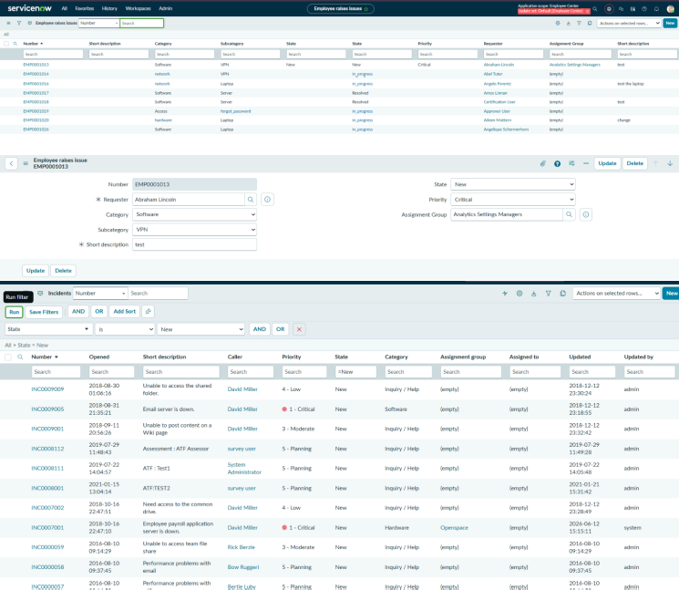  Screenshot / Values
1. | Data Rendered
2. | Data Preprocessing
3. | Utilization of Data Filters
4. | DAX Queries Used | Not Applicable (N/A)
5. | Dashboard design | Number of visualizations/graphs: 0
6 | Report Design | Number of visualizations/graphs: 0

